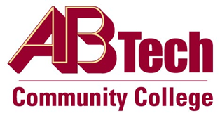

# Asheville-Buncombe Technical Community College (A-B Tech) Policy Manual

## Policy 207.07: Distance Education and Alternate Modes of Instruction

It is the policy of the Board of Trustees to recognize that distance education and alternate modes of instruction are vital to the mission of the College. Distance education and alternate modes of instruction are defined in State Board Code: 1B SBCCC 100.1 Definitions. It is policy that the quality of instruction for courses offered in distance education and alternate modes must be equal to that of courses offered in traditional format.

## Definitions

[1B SBCCC 100.1](https://www.nccommunitycolleges.edu/sbcccode/1b-sbccc-1001-definitions)

Policy Owner

Vice President for Instructional Services, Ext. 7900

References

Reviewed by the Executive Leadership Team, March 7 and 14, 2012, October 23, 2019, and July 12, 2023

See Distance Education and Alternate Modes of Instruction Procedure

Approved by the Board of Trustees on August 7, 2023